**Kubernetes Service accounts**

1. Service account is very similar to the service principal in Azure. Let me tell you the similarities.

|  |  |
| --- | --- |
| **Service Principal** | **Service Account** |
| Need to create in Entra ID | Need to create through Yaml |
| Is created for a subscription | Is created for a namespace |
| Needs to be assigned a role (eg. Contributor) through IAM | Needs to assign a ClusterRole through RoleBinding |
| Service principal is then used by an application (eg. Powershell) | Service account is then used by pods (eg. To list jobs of other namespaces) |

1. Now, as told above, we need to create, a service account, a clusterrole and then a binding (this is imperative only) to bind them. Below are the manifest files and imperative commands.
2. ClusterRole: 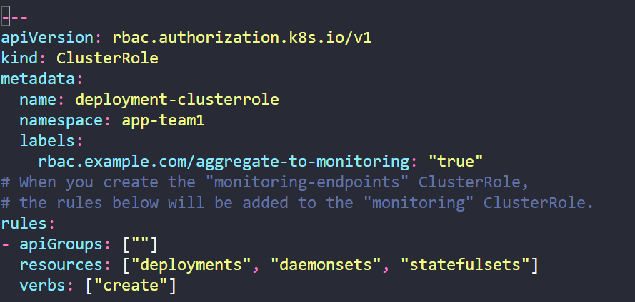
3. Service account: 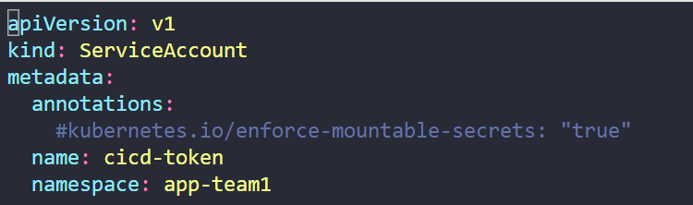
4. Binding: 
5. All in imperative way, 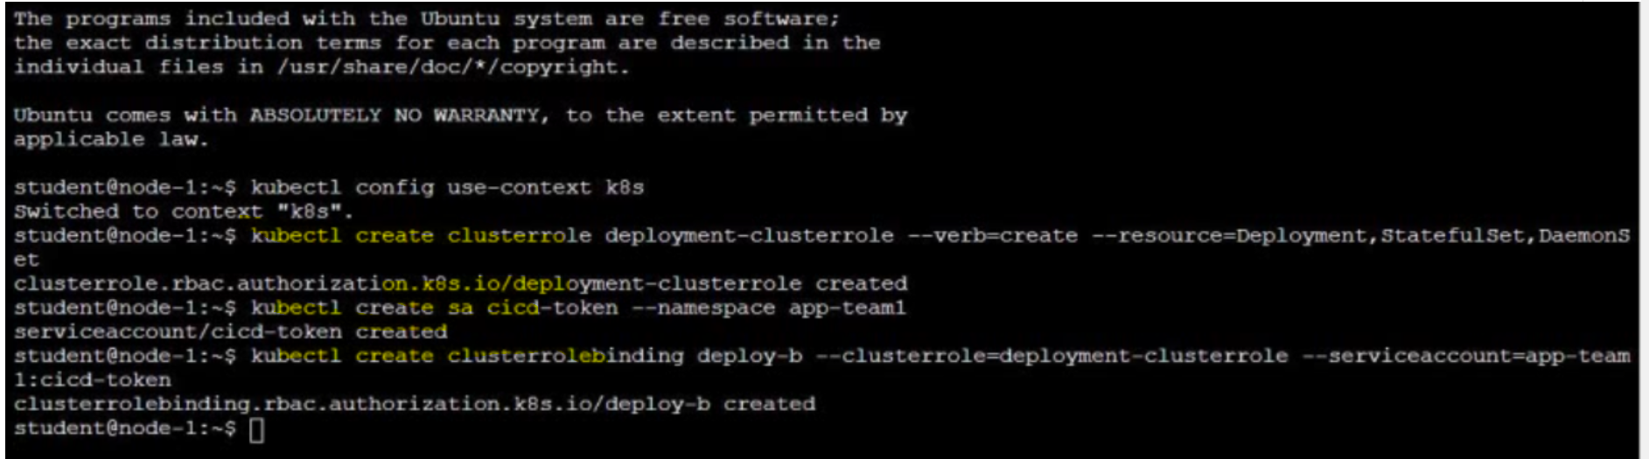
6. Now you can use this Service account in a pod as below, 